Town of Winona Lake
Trash Program

The Town of Winona Lake contracts with Advanced Disposal (wholly-owned subsidiary of Waste Management) to handle the Trash and Recycling services for Winona Lake residents. Below are the highlights of the Town’s Trash Program:

Trash Cart Service:
- Each residential unit will receive one 95-gallon cart. An additional cart may be requested for an additional fee.
- TRASH WILL BE PICKED UP EVERY THURSDAY.
- As mentioned in the Recycling flyer, recycling carts will be emptied every Thursday.
- Up to 2 BULK items can be scheduled for pick-up every other week. You must call (866) 797-9018 to make an appointment with Advanced Disposal/Waste Management.
- THE TOWN-FURNISHED CARTS ARE THE ONLY TRASH CONTAINERS THAT WILL BE EMPTIED.

EXAMPLES OF LARGE BULK ITEMS: furniture, mattresses, gas grills. NOT construction materials,
appliances, propane tanks, cast iron tubs, cast iron bathroom sinks, etc. If you are unsure whether a bulk item is acceptable for pickup, please call Advanced Disposal/Waste Management.

Placing Your Trash Cart for Collection:
- Put all trash in garbage bags; place bagged trash in cart. NOTE: What if you have more trash than what fits in the cart? You may purchase special blue bags at the Town Office ($1/bag) to use for additional trash (that does not fit in your cart). Only trash in the 95-gallon carts and trash placed in these special blue bags will be picked up. (The large BULK items picked up every other week do not need to be placed in the special blue bags.)
- Place your cart no more than 3 feet behind the curb (where you currently place your trash can), with the handle of the cart facing your house. The front of the cart should be facing the street.
- Please keep 3 feet of space between cart and obstructions (e.g., poles, mailboxes, vehicles and recycling carts).
- Always keep the cart lid closed.
- Residents shall place trash cart at the curb by 6:00 am on the designated collection day.

After Trash Cart Collection:
- Remove your empty carts from the curb by midnight of your collection day to your storage area.

Below: Front/side view of trash cart; wheels are on back.
Below: Front view of trash cart.
Below: Photo of special blue bag for extra trash.

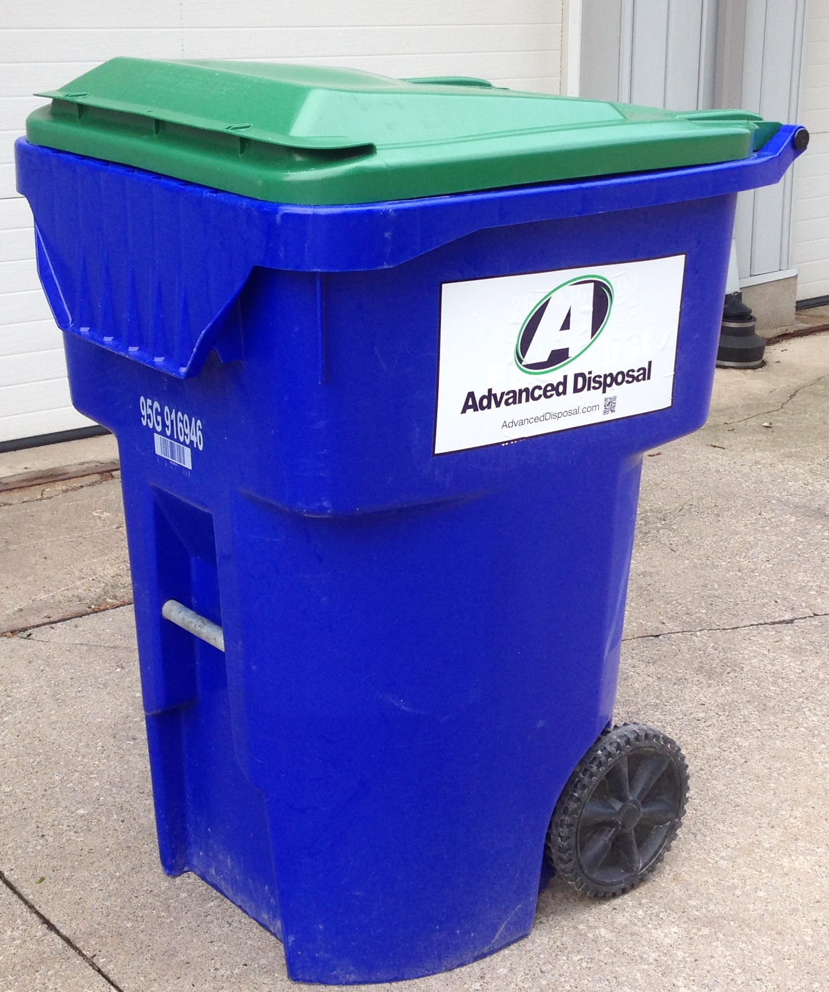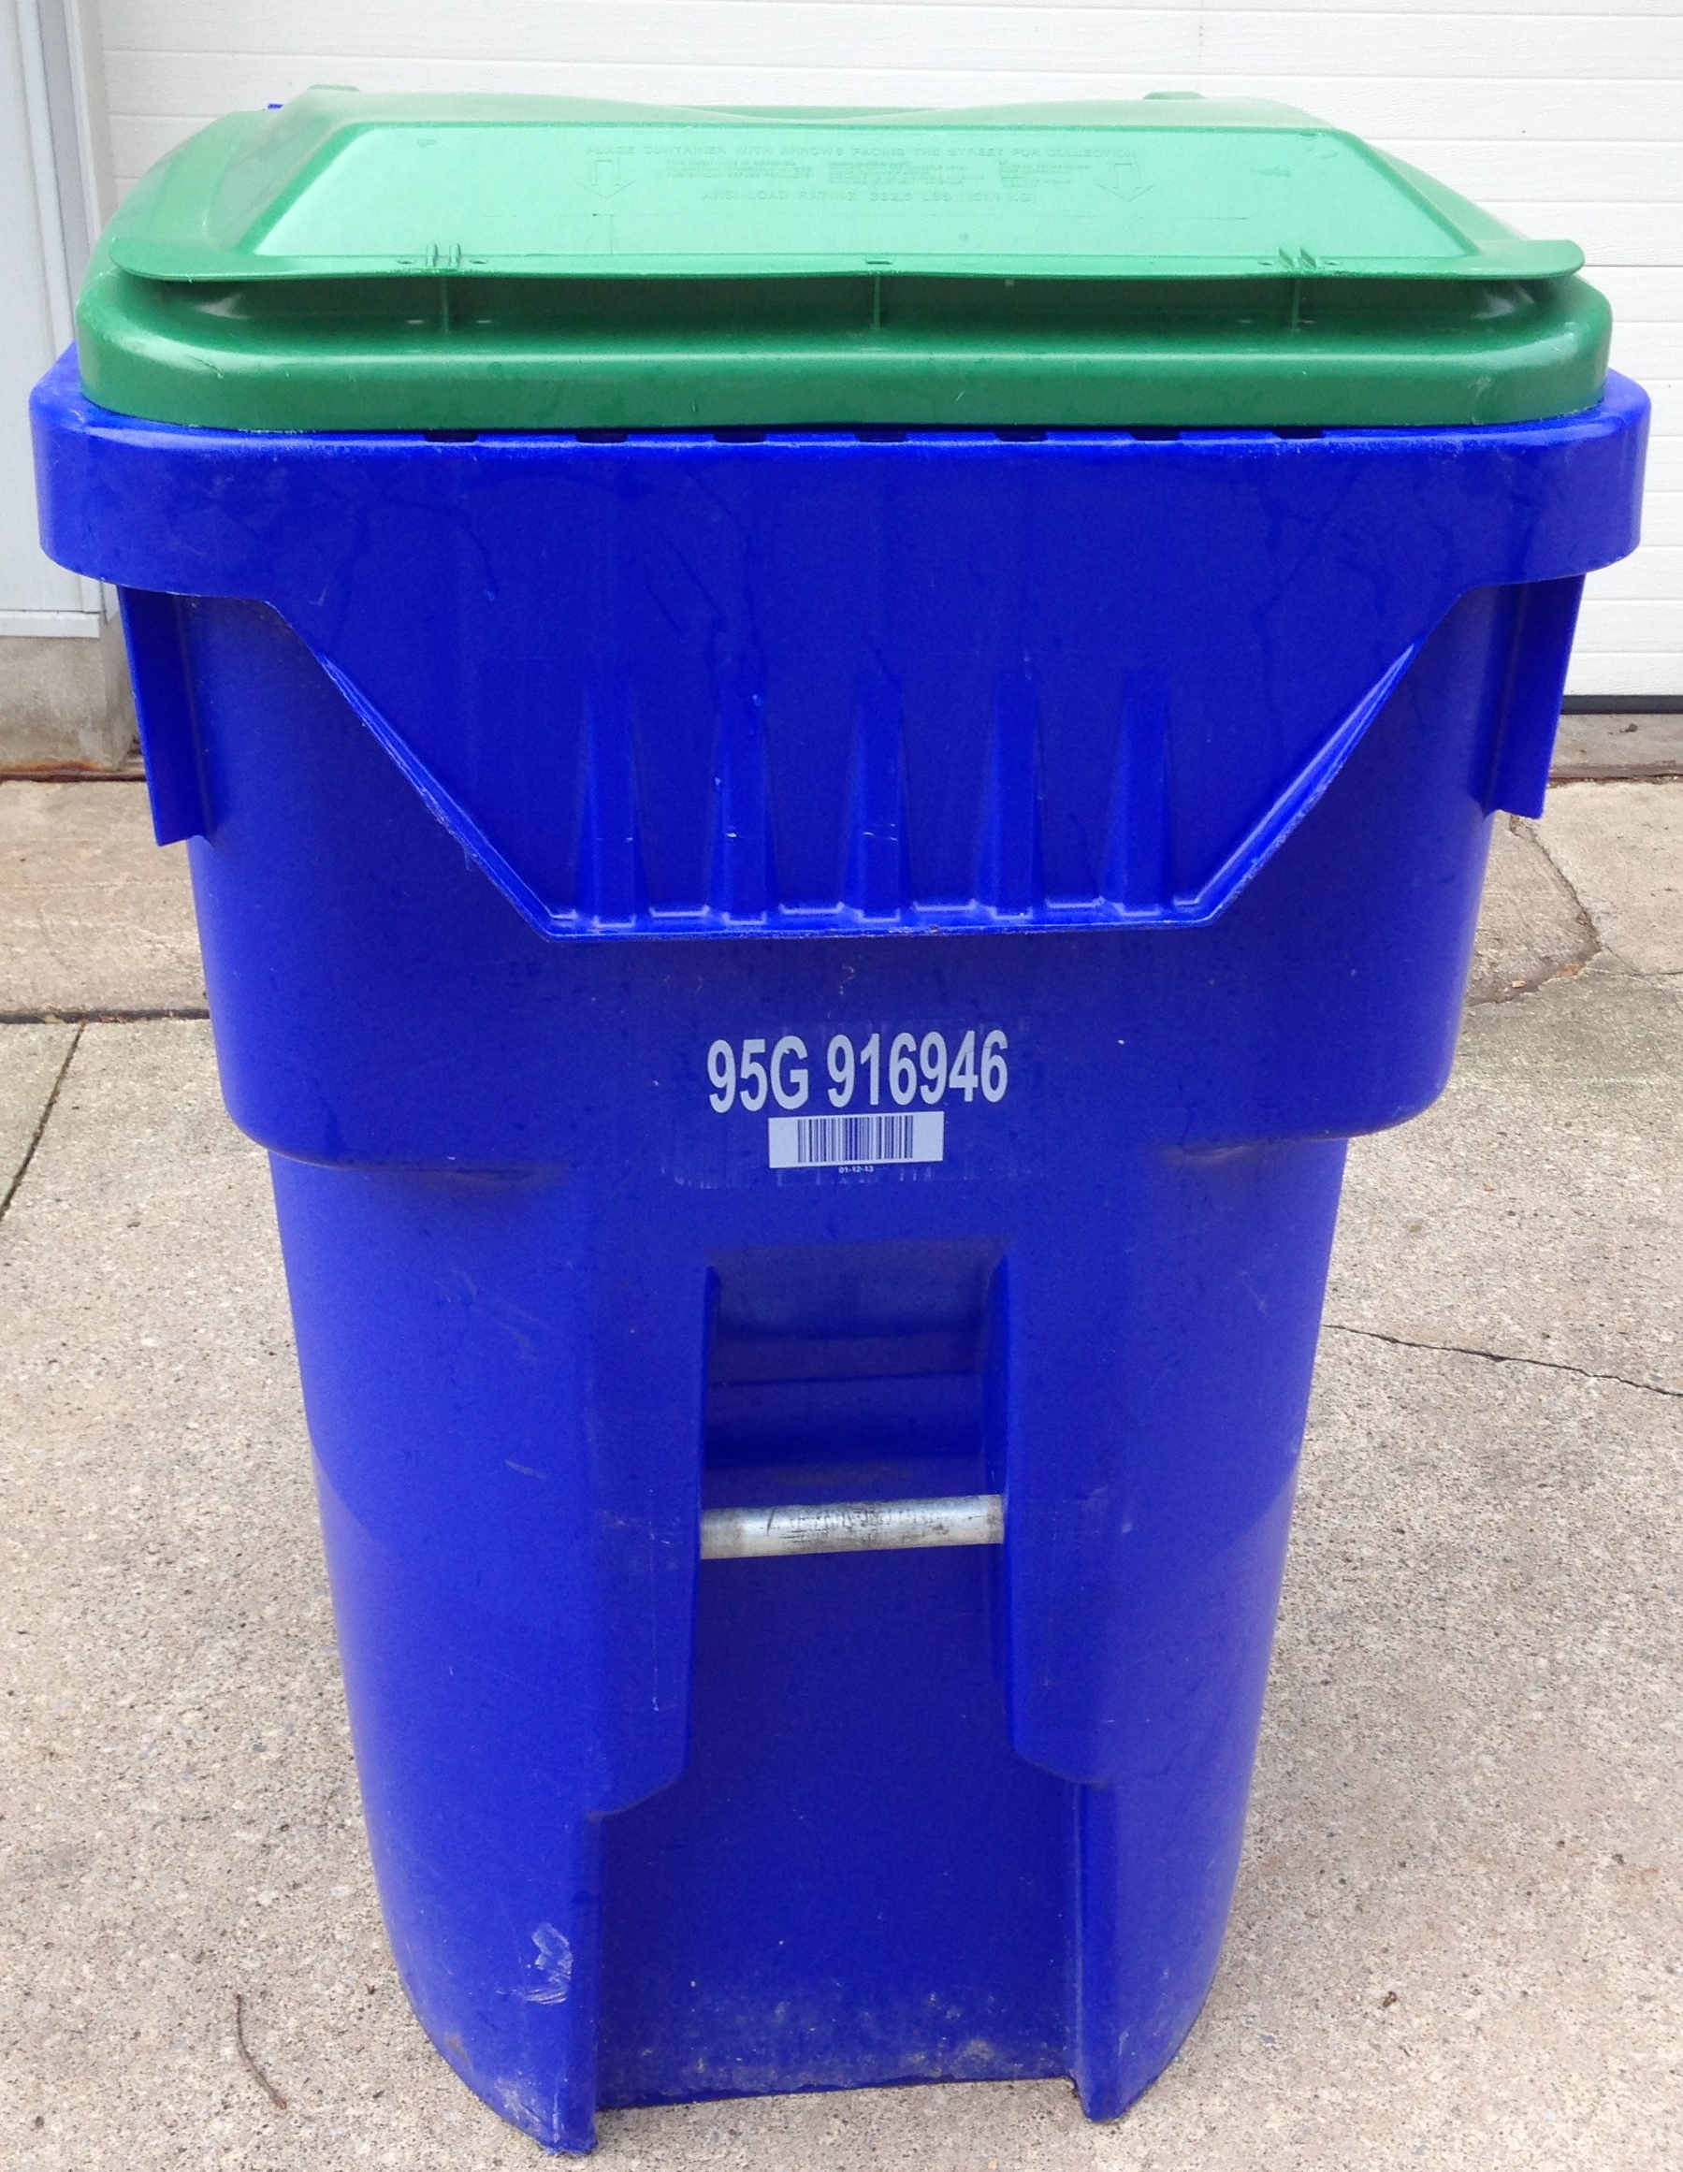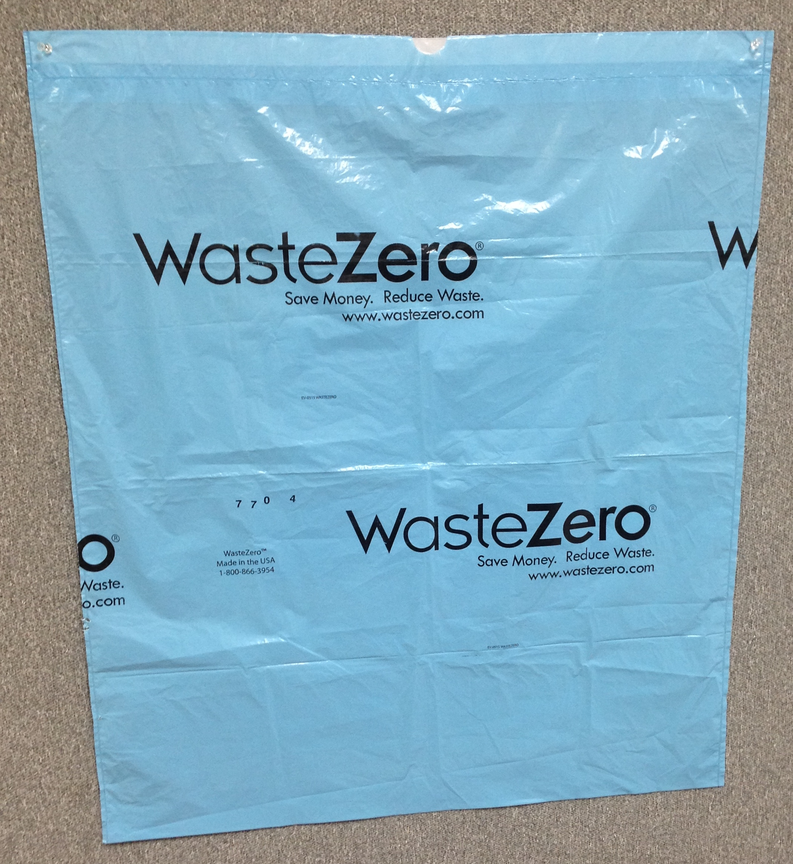

NOTE: Carts may have one of the following logos on them:
- Advanced Disposal logo
- Waste Management logo

Additional Notes:

- Paint disposal – Oil-based paint should not be placed in the trash. KC Recycling Depot collects oil-based paint. Latex (water-based) paint that is dried may be thrown away in the trash as long as the lid is off. To help latex paint dry, mix equal parts of kitty litter or sawdust into your paint and it will dry quickly.

- The Town encourages residents to recycle recyclable items. Please refer to the Recycling Program flyer on the Town website for a list of recyclable items.

- Be a good neighbor and help those who need help handling their recycling and trash carts.

If you have questions as to your trash service, please call the Winona Lake Town Office (574-267-7581) or Advanced Disposal (866-797-9018). The Town of Winona Lake Offices are opened 8am-4pm, weekdays.
REMINDERS:

- Your trash will be picked up every Thursday.

- Your recycling will be picked up every other Thursday on your designated week.

- Up to 2 bulk items will be picked up every other week – by appointment only.

- Both the Recycling Program flyer and Trash Program flyer are posted on the Town website: winonalake.net.

Thank you for your cooperation. Let’s keep Winona Lake beautiful!

Revised 8-17-2021

